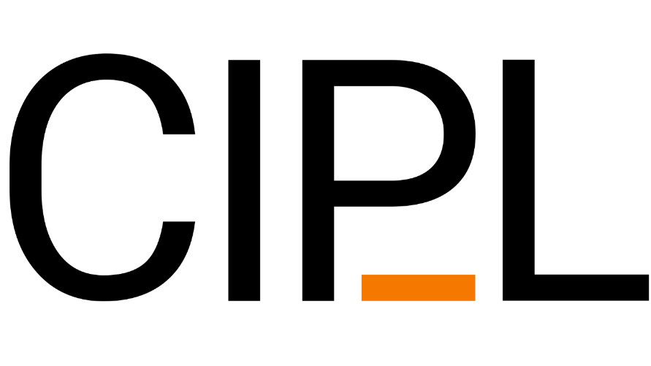
____________
Annual Report
2020

Contents
__________________________________________________________________________________

Introduction 3
Executive Committee 4
General Assembly 5
Members 7
Linguistic Bibliography and Linguistic Bibliography Online 8
International Congress of Linguists 10
CIPSH Chair Ethnolinguistic Vitality and Diversity in the World 11
Newsletter 12
Travel grants 13
Future priorities 14
Finances 15
Introduction
________________________________________________________

It is with great pleasure that we present the Annual Report 2020.
Despite the COVID-19 pandemic, we were able to publish two newsletters and start the organisation of the next international conference. Once the decision had been taken and published that XXI ICL will take place in Kazan in 2023 and the SC had been installed, we focus on the theme of the conference, keynote speakers and sections. The proposal was elaborated in an informal consultation between the President, Vice-President and Secretary-General of CIPL, the Scholarly Vice-President of XXI ICL Kazan 2023 and some other members of the SC. The theme of the conference is “Stepping up towards broader linguistics”.
A number of main sections and focus streams were identified for the conference.
Due to the pandemic, no live events took place in 2020, but the linguistic community got stronger and closer in organising online events. Some of our members took the lead in organising a multitude of lectures that could be followed all over the world. We refer to Abralin a Vivo, but other linguistic organisations also took initiatives in this new mode of sharing ideas.
New members also joined CIPL, one of them being the Network of Linguistic and Socio-cultural Archives of South America that was newly established and covers different countries in South America.
CIPL took part in online conferences with CIPSH and represented the field of linguistics within the larger context of the humanities.
The LB online is growing with a substantial number of new records, and the project on retro-digitization of early volumes of the LB was launched. Sacha Lubovsky joined the board of the LB, in replacement of Wim Vandenbussche, whose term as a board member had come to an end.

Executive Committee
___________________________________________________________________________

Prof David Bradley, President (Australia)
Prof Ik-Hwan Lee, Vice-President (Korea)
Prof Frieda Steurs, Secretary-General (Belgium/The Netherlands)
Prof Dermeval da Hora, member (Brazil)
Prof Raj Mesthrie, member (South Africa)
Prof Fritz Newmeyer, member (Canada)
Prof Victoria Rau, member (Taiwan)
Prof Eno-Abasi Urua, member (Nigeria)

Prof Camiel Hamans: Associate Secretary-General
Prof Piet van Sterkenburg: Honorary Secretary-General
Prof Reinier Salverda: Special delegate for the UNESCO Atlas of the World's
Languages in Danger
For email addresses etc. check CIPL’s website: http://www.ciplnet.com/addresses-executive-committee

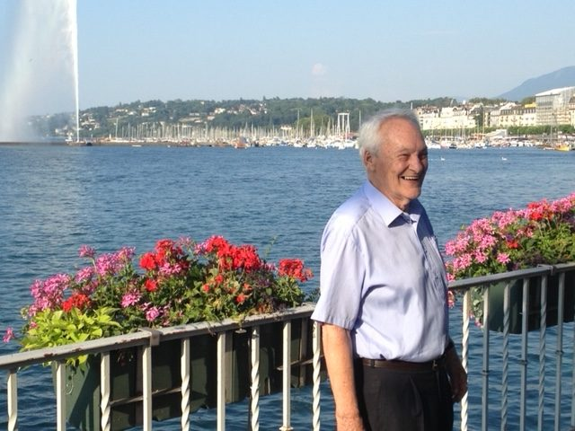
● Professor Ferenc Kiefer

In 2020 we were sad to hear about the loss of our former President, professor Kiefer.
Ferenc Kiefer will be remembered best as the ambassador for linguistics par excellence and the engaging, friendly person who had an encouraging word for everyone he met. With his knowledge of many languages, he was able to easily access everyone’s heart. His passing away is a great loss for the study of the Hungarian language and for linguistics. He will be sorely missed by his friends and colleagues.

General Assembly
__________________________________________________________________________________

Argentina » The Network of Regional Linguistic and Sociocultural Archives in South America; Prof Lucia Golluscio, Prof Alejandra Vidal and Prof Felipe Hasler
Australia » The Australian Linguistic Society: Prof David Bradley
Austria » Wiener Sprachgesellschaft: Prof Bernhard Hurch
Belgium » The Linguistic Society of Belgium: Prof Timothy Colleman
» International Pragmatics Association (IPrA): Prof Jef Verschueren
» The Historical Sociolinguistics Network (HiSoN): Prof Wim Vandenbussche
Brazil » The Brazilian Association of Linguistics (ABRALIN): Prof Miguel Oliveira, Jr
» The Latin American Association for Linguistics and Philology:
Prof Dermeval da Hora
Canada » The Canadian Linguistic Association: Prof Fritz Newmeyer
Czech Republic » Charles University MFF: Prof Eva Hajicova
Finland » The Linguistic Association of Finland: Prof Marja-Liisa Helasvuo
France » Société de Linguistique de Paris: Prof Alain Lemaréchal
» Société d'histoire et d'épistémologie des sciences du langage:
Prof Camiel Hamans
Georgia » Giorgi Akhvlediani Society for the History of Linguistics:
Prof Tinatin Bolkvadze
Germany » Deutsche Gesellschaft für Sprachwissenschaft: Prof Miriam Butt
Hungary » Research Institute for Linguistics/Hungarian Academy of Sciences:
Prof Istvan Kenesei
Ireland » The School of Celtic Studies of the Dublin Institute of Advanced Studies:
Prof Liam Breatnach
Israel » Societatis Linguisticae Europaeae Sodalicium Israelense: Prof Ariel Cohen
Italy » Società Italiana di Glottologia, Società di Linguistica Italiana & Accademia
della Crusca: Prof Giuliano Bernini
Japan » Linguistic Society of Japan: Prof Shigeki Kaji
Korea » Linguistic Society of Korea: Prof Ik-Hwan Lee
Latvia » Latvian Language Institute: Dr Agris Timuska
Lithuania » The Lithuanian Academy of Sciences: Prof Bonifacas Stundzia
Netherlands » Max Planck Institute for Psycholinguistics: Prof Pieter Seuren
» Frisian Academy: Prof Reinier Salverda
» Societas Linguistica Europaea: Prof Camiel Hamans
» Algemene Vereniging voor Taalwetenschap: Dr Jenneke van der Wal
» The Dutch Language Institute: Prof Frieda Steurs
Nigeria » Linguistic Association of Nigeria: Prof Eno-Abasi Urua
Norway » Norwegian Academy of Science and Letters: Prof John Ole Askedal
Poland » Polish Academy of Sciences: Prof Elzbieta Manczak-Wohlfeld
Portugal » Center for the Studies in Letters: Prof Gonҫalo Fernandes
» Portuguese Linguistic Association: Prof Ana Maria Brito
» Centro de Linguística da Universidade de Lisboa; Prof Hugo Cardoso
Russian federation
» Institute of Linguistics of the Russian Academy of Sciences: Prof Andrej Kibrik
Serbia » The Applied Linguistics Association of Serbia: Prof Vesna Polovina
South Africa » Southern African Linguistics and Applied Linguistics Society: Dr Herculene Kotzé
Spain » Sociedad Española de lingüística: Prof Manuel Leonetti
» Royal Academy for the Basque Language – Euskaltzaindia – :
Prof Andrés Urrutia Badiola
Switzerland » The Swiss Linguistics Society: Prof Jacques Moeschler
Taiwan » Linguistic Society of Taiwan: Prof D. Victoria Rau
Trinidad &Tobago
» Society for Caribbean Linguistics : Dr Jo-Anne Ferreira
Turkey » Turkish Linguistics Association: Prof Deniz Zeyrek Bozşahin
Ukraine » O. O. Potebnya Institute of Linguistics of the National Academy of Sciences
of Ukraine: Dr Serhiy Yermolenko
United Kingdom » The Philological Society and the Linguistics Society of Great Britain:
Prof Aditi Lahiri
» International Society for Historical Linguistics (ICHL): Mr John Charles Smith
» The International Congress of Celtic Studies:
USA » Linguistic Society of America: Prof. Andries W. Coetzee
For email addresses etc. check CIPL’s website: http://www.ciplnet.com/addresses-general-assembly

Members
___________________________________________________________________________

All organisations and institutions whose main aims include the promotion of linguistic science and the advancement of co-operation among linguists, may become members.

An organisation or institution may join CIPL by applying to the Executive Committee (through the Secretary-General). The organisation/institution has to appoint a delegate in CIPL's General Assembly who meets every five years during the ICL.

In 2020 efforts were also made to increase the number of members. The
Network of Regional Linguistic and Sociocultural Archives in South America, Centro de Linguística da Universidade de Lisboa and the Society for Caribbean Linguistics (Trinidad & Tobago) joined CIPL in 2020.

Linguistic Bibliography
and Linguistic Bibliography Online
__________________________________________________________________________________

Linguistic Bibliography Yearbook for 2019
The LB print volume for the year 2019 was published on schedule in September 2020. The volume contains 22,089 entries, close to the number of entries in the previous yearbook (22,195), which appears to be the maximum number that the linen-bound volume is physically able to hold. As the first complete proof of the 2019 yearbook exceeded the maximum number of pages (1,616), some entries for publications published before 2019 were removed from the print edition but still included in the online edition. These comprised journal articles from the year 2015 and older book entries of which a review was published between 2015-2018. Older books that were reviewed in 2019 still appeared in the print edition.

LB yearbook 2020
In order to prevent overflow in the next yearbook, the LB/LBO editorial has instituted a new policy. Only bibliographical descriptions of books, articles, and reviews published in 2020 will be included in the 2020 yearbook, while new entries submitted for older publications will be published on LBO only. If the number of entries for the print edition is below the maximum, they will be supplemented by selected older publications that are up to five years old, with priority given to those from 2019. This will remain our policy for future volumes.
Currently, 8,400 entries are set to be published in the next yearbook, a lower number than usual (for comparison: 11,869 entries collected by this time last year), so the expectation is that the yearbook will be supplemented with older material. While the LB editors are mainly collecting publications from 2020, there has been a large influx of older materials (as usual) from the external contributors. The yearbook is expected to be published in September 2021.

Linguistic Bibliography Online (LBO)
In 2020, the online database saw an increase of 24,746 bibliographical records. In 2020, 54 new journals were added to the list of periodicals covered by the LB. Non-linguistic journals that are occasionally checked for linguistic content are not included here. A total of 227 new language keywords were implemented in the database. The keyword system for Khoisan languages and language families was revised and expanded in line with the latest consensus in Khoisan classification research.
A total of 97 new subject keywords were implemented in the database.

CMS (content management system)
In 2020, software developer Ambrac continued work (off and on) on time-saving templates for creating new bibliographical records and software for harvesting and importing online bibliographical data. Several prototype versions were tested, and the results will be implemented in the CMS in the future.

Retro-digitization
The retro-digitization of older yearbooks (covering 1939-1992) was set in motion and the first batches of digitized records have been made available for scrutiny and subsequent feedback. Currently the OCR (optical character recognition) methods are being fine-tuned in order to output XML-data that needs a minimum of processing before it can be incorporated into the LB database and subsequently made available to our clients. The project end is planned to be concluded in 2024/5.

New bibliographies platform
In 2020, Brill appointed a team to explore the possibility of developing a new online platform for bibliographies, centered around improved functionality and user-friendliness. LB Editor Eline van der Veken was regularly involved in formulating platform requirements and data testing.

Contributors
The editorial team is always on the look-out for contributors, particularly for experts in Armenian, Baltic (Lithuanian, Latvian, Prussian etc.), Catalan, P-Celtic (Welsh, Breton, Cornish), and Thai. Potential contributors may be referred to brill.com/page/lbcontributor for more information.

International Congress of Linguists
_________________________________________________________________

The upcoming International Congress of Linguists, ICL21, will take place in Kazan (Tatarstan, Russia) from 25 June to 2 July 2023.
ICL21 will be jointly organised by Kazan Federal University and the Institute of Linguistics of the Russian Academy of Sciences in Moscow.
Honorary President of the conference will be the President of the Republic of Tatarstan, Mr Rustam Minnikhanov.
The Congress Presidents will be Prof Ilshat Gafurov, Rector of Kazan Federal University, and Dr Andrej A. Kibrik, Director of the Institute of Linguistics of the Russian Academy of Sciences and Professor of Lomonosov Moscow State University, Moscow.
Prof David Bradley, President of CIPL, will chair the Scientific Committee.
Prof Camiel Hamans, Associate Secretary-General of CIPL, will act as Secretary-General of the Congress.
In due course, a website will be opened on which further information about the substantive and organisational aspects of the conference will be published. Registration will be opened in 2022.
Further information on ICL21 can be obtained from Prof Frieda Steurs, Secretary-General of CIPL (frieda.steurs@ivdnt.org), or Prof Camiel Hamans (hamans@telfort.nl).

CIPSH Chair Ethnolinguistic Vitality and Diversity
in the World
__________________________________________________________________________________
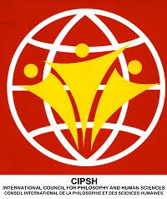

Due to the fruitful cooperation between the Comité International de Philosophie et Sciences Humaines (CIPSH), CIPL and the University of Leiden, a special chair on endangered languages has been established. “The chair on ethnolinguistic vitality and diversity” will advance research and practice of language documentation.

The chair will develop several activities that promote and increase interest in the advantages of linguistic diversity, multilingualism and the maintenance of the vitality of minority and threatened languages. In doing this the chair will promote a language policy based on diversity, which will lead to a better knowledge of cultures and of the richness of different cultures, which is one of CIPSH’s priorities.

The chair will build a network between important universities and other research institutes in order to offer both teaching and training, summer schools, workshops and conferences. This fits in perfectly well with the CIPSH mission statement to highlight and encourage existing research networks of centres of research in the humanities and to attract greater attention to the humanities worldwide and enhance recognition of their importance in contemporary society.

In 2020 and 2021 all the activities with regard to the CIPL/CIPSH Chair had to be postponed due to the COVID-19 crisis.

In 2022, with the support of CIPL, the chair is hoping to organise a workshop on indigenous languages of South America in Brazil to discuss interdisciplinary methods of language and culture documentation in that part of the world.

In 2023, CIPL will hold its 21st International Congress of Linguists. The chair will organise panels on ethnolinguistic vitality and language policy as an integral part of the conference.

Newsletter __________________________________________________________________________________

In CIPL’s annual report over 2018 we mentioned as one of our future priorities a newsletter. We were very happy to publish our first newsletter in October 2019. The letter was sent to our member organisations with the request to forward this newsletter to their members. The newsletter was also published via the Linguist List.
We strongly encourage CIPL’s representatives to inform their colleagues and students about our newsletter. Also, we warmly welcome any information regarding linguistics to be published in our newsletter.

For 2020, two newsletters were published, in March and October. In these Newsletters there were two interviews: with Prof Ferenc Kiefer and with Prof Tjeerd de Graaf.

Furthermore, in these Newsletters several new CIPL members introduced themselves: Centro de Linguística da Universidade de Lisboa (Portugal), the Society for Caribbean Linguistics (Trinidad & Tobago) and the Société d'histoire et d'épistémologie des sciences du langage (France).

Other issues were: Travel grants, Bibliographie Linguistique, ICL21, Workshops and virtual conferences.

All our Newsletters can be found on our website.

Travel grants
__________________________________________________________________________________

Every year CIPL awards 5 travel grants of € 500 each (approx. US$ 550). Advanced students in linguistics without a PhD are eligible to receive a once-only grant to help fund their participation in a linguistics conference.

A special committee chaired by Prof Dr Frederick J. Newmeyer has assessed the applications.

Travel grants, Spring/Summer 2020
In the spring/summer CIPL awarded three travel grants to:
Melissa Irvine, University of Auckland, New Zealand, for participation in the 23rd Biennial Conference of the Society for Caribbean Linguistics to be held in Trinidad and Tobago.
Victoria Leonetti Escandel, Universidad Complutense de Madrid, Spain, for participation in the conference ‘Processing of Reference and Anaphora Resolution’ to be held in Brussels.
Teja Rebernik, University of Groningen, Netherlands, for participation in the 12th International Seminar on Speech Production to be held in Providence.

Travel grants Autumn 2020
In the autumn CIPL awarded three travel grants to:
Natalia Kuznetsova, Università degli Studi di Torino, Italy, for participation in the XIII International Congress of Finno-Ugrists, CIFUXIII, to be organised by the Universität Wien, Vienna, Austria.
Shirly Orr, Tel Aviv University, Israel, for participation in the International Workshop on Subjectivity and Intersubjectivity to be organised by the Università degli Studi del Piemonte Orientale “Amedeo Avogadro” , Vercelli, Italy.
Paula Schintu Martínez, Universidad de Salamanca, Spain, for participation in the 7th International Congress of Late Modern English, LmodE-7, to be organised by Università degli Studi di Catania, Ragusa Ibla, Italy.
Due to the COVID-19 pandemic most of the 2020 conferences have been postponed, organised online or canceled. Melissa Irvine was able to ‘attend’ an online conference. The conferences Victoria Leonetti Escandel, Teja Rerbernik and Shirly Orr wanted to participate in were unfortunately cancelled.
The Congresses Natalia Kuznetsova and Paula Schintu Martínez want to attend were postponed to 2021.

Future priorities
__________________________________________________________________________________

In 2021 we will introduce our new website. This site will be hosted at the Dutch Language Institute in the Netherlands with a splendid computer infrastructure and a professional webmaster.
The new website will offer a lot of space for news, and subscribing to our newsletter will become much easier.

With regard to the Chair of Ethnolinguistic Vitaly and Diversity in the World, in 2021 a foundation for endangered languages will be established in order to collect additional funding for activities and scholarships to support the activities of the Chair.

The ICL21 in Kazan will take up a lot of our time and attention; we will have to set out a first call for papers and start preparing a lot of different aspects of the conference. If there are no travel limitations due to COVID, a visit will be made to Kazan by the Secretary-General and the associate Secretary-General in 2020.
CIPL will also take part in the 50th Poznań Linguistic Meeting (PLM) that was planned for 2020, but due to the health crisis was postponed until 2021. CIPL is responsible for two tracks in this conference, viz. Future of less-favoured languages: Indigenous, regional and minority status, and How language technology supports multilingualism and language variety in the modern world.

Finances
__________________________________________________________________________________

Please find enclosed the Financial Statements. The 2020 Annual Report is approved.

Leiden, December 31 2020

Prof D. Bradley, President CIPL

Prof F. Steurs
Secretary-General

